Lab 10

Finite State Machine

ECE 380-002

University of Alabama

Yichen Huang

Thomas Dillman

2019/11/18

**Introduction**

In this lab, we mainly focus on the designing of two type of finite state machine (FSM) which are Moore-type and Mealy-type. These two machines will detect the input, when the inputs contain sequence of 100, the output will be 1 else the output will be 0.

**Procedure**

1. **Prelab**

In the prelab, we draw the bubble diagram of two machine. In the picture, diagram A is Moore-type finite state machine and diagram B is Mealy-type finite state machine.

* 1. **Design A**

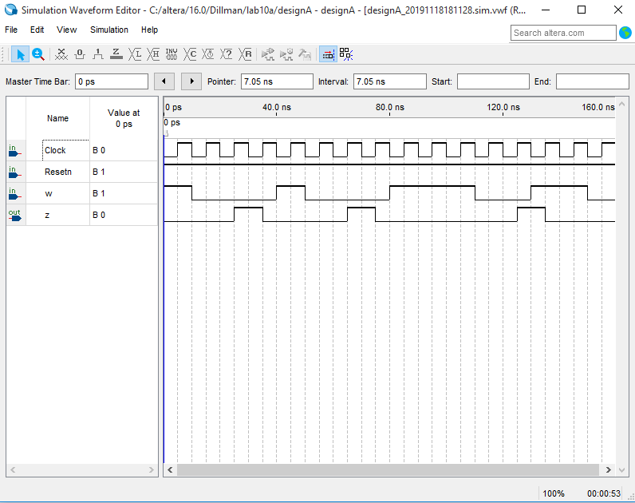In the design A, we redesign the VHDL code and make some change to let the machine can detected the sequence.

* 1. **Design B**

In the design B, we just design the same finite state machine but in the Mealy type.

1. **During the lab**
   1. **Design A**

During the lab, we assign the pins of the design to the DE1 board. Then we upload the design to the lab and finally we do the test manually.

* 1. **Design B**

In the design B, we repeat the same procedure in the design A.

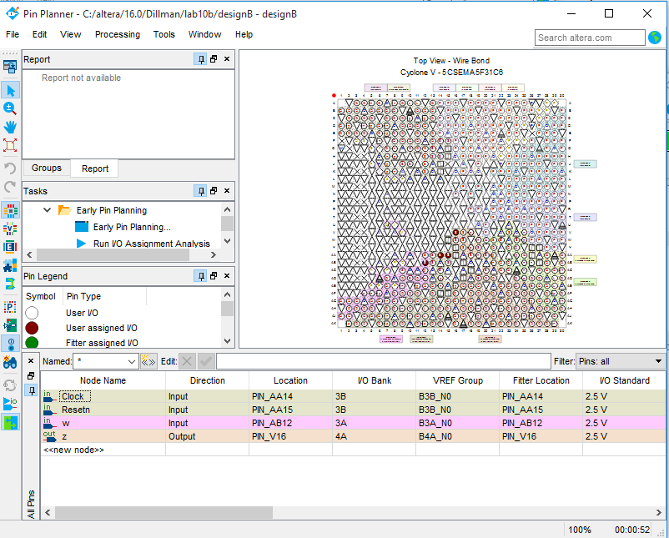

**Result**

In the result of the board is same as we test in the prelab.

**Conclusion**